This Project can only be run on a Mac OS computer

To run this project please follow the instruction below

1. Download Xcode 8 application from developer.apple.com (require MacOS Sierra)
2. Open the project folder (Survey) and open the file Survey.xcodeproj
3. On the top left corner of your screen please make sure that the connected iPad device is selected

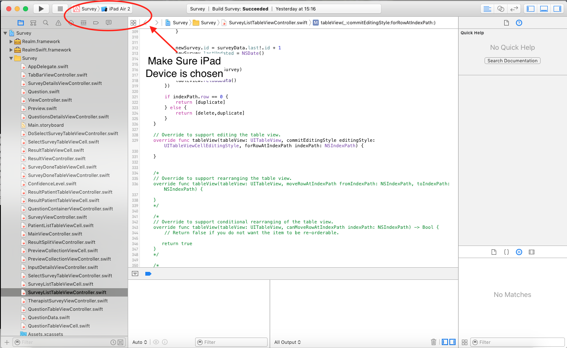

1. In the icon on the right of Stop icon make sure you have select the project name and not any framework
2. When you press the play icon and code complies a message “Build Succeed” will pop up and the app will open with splash screen of this application

Note: If you would like to install the application into your iPad device, the device UDID need to be registered to Paul Roberts along with linking it with provisioning profile *Survey* and make sure the iPad has iOS 10.